# [ 2CEIT5PE5: MOBILE APPLICATION DEVELOPMENT]

Practical: 9



**AIM- What is Difference between ListView and RecyclerView? Create SMS Android Application that can receive SMS by BroadcastReceiver and Interface, Send SMS and read & display all SMS of Inbox by using RecyclerView according to below instructions.**

Submitted By: Dhruv.S.Lakhani

Enrollment number: 20012011055



## Department of Computer Engineering/Information Technology

**Practical-9**

# AIM:- What is Difference between ListView and RecyclerView? Create SMS Android Application that can receive SMS by BroadcastReceiver and Interface, Send SMS and read & display all SMS of Inbox by using RecyclerView according to below instructions.

## Activity_main.xml:-

<androidx.constraintlayout.widget.ConstraintLayout xmlns:android="http://schemas.android.com/apk/res/android"  
 xmlns:app="http://schemas.android.com/apk/res-auto"  
 xmlns:tools="http://schemas.android.com/tools"  
 android:layout_width="match_parent"  
 android:layout_height="match_parent"  
 tools:context=".MainActivity">  
  
 <com.google.android.material.card.MaterialCardView  
 android:id="@+id/card"  
 android:layout_width="match_parent"  
 android:layout_height="wrap_content"  
 app:layout_constraintBottom_toTopOf="@id/l1"  
 app:layout_constraintEnd_toEndOf="parent"  
 app:layout_constraintStart_toStartOf="parent"  
 app:layout_constraintTop_toTopOf="parent"  
 app:cardCornerRadius="7dp"  
 app:cardElevation="7dp"  
 android:layout_marginTop="10dp"  
 android:layout_marginHorizontal="20dp">  
 <ListView  
 android:id="@+id/listView"  
 android:layout_width="match_parent"  
 android:layout_height="500dp"  
 android:backgroundTint="@color/cardview_shadow_end_color"/>  
 </com.google.android.material.card.MaterialCardView>  
 <LinearLayout  
 android:id="@+id/l1"  
 android:layout_width="match_parent"  
 android:layout_height="wrap_content"  
 android:weightSum="100"  
 app:layout_constraintStart_toStartOf="parent"  
 app:layout_constraintEnd_toEndOf="parent"  
 app:layout_constraintTop_toBottomOf="@id/card"  
 app:layout_constraintBottom_toBottomOf="parent"  
 android:orientation="horizontal"  
 android:layout_margin="20dp">  
  
 <LinearLayout  
 android:layout_weight="90"  
 android:layout_width="match_parent"  
 android:layout_height="wrap_content"  
 android:orientation="vertical">  
 <com.google.android.material.textfield.TextInputLayout  
 android:id="@+id/phoneNoInput"  
 android:layout_width="match_parent"  
 android:layout_height="wrap_content"  
 android:hint="Mobile No"  
 app:endIconMode="custom"  
 app:endIconDrawable="@drawable/ic_baseline_phone_24"  
 style="@style/Widget.MaterialComponents.TextInputLayout.OutlinedBox">  
  
 <com.google.android.material.textfield.TextInputEditText  
 android:id="@+id/phoneNo"  
 android:layout_width="match_parent"  
 android:layout_height="wrap_content"/>  
  
 </com.google.android.material.textfield.TextInputLayout>  
 <com.google.android.material.textfield.TextInputLayout  
 android:id="@+id/msgInput"  
 android:layout_width="match_parent"  
 android:layout_height="wrap_content"  
 android:hint="Message"  
 app:endIconMode="custom"  
 app:endIconDrawable="@drawable/ic_baseline_message_24"  
 style="@style/Widget.MaterialComponents.TextInputLayout.OutlinedBox">  
  
 <com.google.android.material.textfield.TextInputEditText  
 android:id="@+id/msg"  
 android:layout_width="match_parent"  
 android:layout_height="wrap_content"/>  
 </com.google.android.material.textfield.TextInputLayout>  
 </LinearLayout>  
 <com.google.android.material.floatingactionbutton.FloatingActionButton  
 android:id="@+id/sendButton"  
 app:fabSize="normal"  
 android:layout_marginTop="35dp"  
 android:layout_width="wrap_content"  
 android:layout_height="wrap_content"  
 android:layout_marginHorizontal="10dp"  
 android:src="@drawable/ic_baseline_send_24"/>  
 </LinearLayout>  
</androidx.constraintlayout.widget.ConstraintLayout>

## Sms_item_view.xml:-

## <?xml version="1.0" encoding="utf-8"?> <LinearLayout xmlns:android="http://schemas.android.com/apk/res/android" android:layout_width="match_parent" android:layout_height="match_parent" android:orientation="horizontal" android:layout_marginHorizontal="10dp"> <ImageView android:id="@+id/icon" android:layout_width="60dp" android:layout_height="60dp" android:padding="5dp" android:background="@drawable/shape" android:src="@drawable/ic_baseline_person_24"/> <LinearLayout android:layout_width="wrap_content" android:layout_height="wrap_content" android:orientation="vertical"> <TextView android:id="@+id/textViewPhoneNo" android:layout_width="wrap_content" android:layout_height="wrap_content" android:text="Medium Text" android:textStyle="bold" android:textAppearance="?android:attr/textAppearanceMedium" android:layout_marginLeft="10dp" android:layout_marginTop="5dp" android:padding="2dp" android:textColor="#4d4d4d" /> <TextView android:id="@+id/textViewMessage" android:layout_width="wrap_content" android:layout_height="wrap_content" android:text="TextView" android:layout_marginLeft="10dp"/> </LinearLayout> </LinearLayout>

## MainActivity.kt:-

package com.example.madpractical9_20012011055  
  
import android.Manifest  
import android.content.IntentFilter  
import android.content.pm.PackageManager  
import android.net.Uri  
import androidx.appcompat.app.AppCompatActivity  
import android.os.Bundle  
import android.provider.Telephony  
import android.telephony.SmsManager  
import android.widget.ListView  
import androidx.appcompat.app.AlertDialog  
import androidx.core.app.ActivityCompat  
import androidx.core.content.ContextCompat  
import com.example.madpractical9_20012011055.databinding.ActivityMainBinding  
  
class MainActivity : AppCompatActivity() {  
 private lateinit var binding : ActivityMainBinding  
 private val SMS_PERMISSION_CODE = 100  
 private lateinit var lv: ListView  
 private lateinit var al: ArrayList<SMSView>  
 private lateinit var smsReceiver:SMSBroadcastReceiver  
 override fun onCreate(savedInstanceState: Bundle?) {  
 super.onCreate(savedInstanceState)  
 binding = ActivityMainBinding.inflate(*layoutInflater*)  
 setContentView(binding.*root*)  
 lv = binding.listView  
 al = ArrayList()  
  
 if(checkRequestPermission()){  
 loadSMSInbox()  
 }  
 smsReceiver = SMSBroadcastReceiver()  
 registerReceiver(smsReceiver, IntentFilter(Telephony.Sms.Intents.*SMS_RECEIVED_ACTION*))  
 smsReceiver.setListner(ListenerImplement())  
 binding.sendButton.setOnClickListener**{** val phone = binding.phoneNo.*text*.*toString*()  
 val msg = binding.msg.*text*.*toString*()  
 sendSms(phone,msg)  
 }}  
 private fun sendSms(sPhoneNo: String?,sMsg: String?){  
 if(!checkRequestPermission()){  
 return  
 }  
 val smsmanager = SmsManager.getDefault()  
 if(smsmanager != null){  
 smsmanager.sendTextMessage(sPhoneNo,null,sMsg,null,null)  
 }  
 }  
 inner class ListenerImplement:SMSBroadcastReceiver.Listner{  
 override fun onTextReceived(sPhoneNo: String?, sMsg: String?) {  
 val builder : AlertDialog.Builder = AlertDialog.Builder(this@MainActivity)  
 builder.setTitle("New SMS Received")  
 builder.setMessage("$sPhoneNo\n$sMsg")  
 builder.setCancelable(true)  
 builder.show()  
 loadSMSInbox()  
 }  
 }  
 private val isSMSReadPermission: Boolean  
 get() = ContextCompat.checkSelfPermission(this, Manifest.permission.*READ_SMS*) == PackageManager.*PERMISSION_GRANTED* private val isSMSWritePermission: Boolean  
 get() = ContextCompat.checkSelfPermission(this, Manifest.permission.*SEND_SMS*) == PackageManager.*PERMISSION_GRANTED* private fun requestSMSPermission() {  
 if (ActivityCompat.shouldShowRequestPermissionRationale(this, Manifest.permission.*READ_SMS*)) {  
 // You may display a non-blocking explanation here, read more in the documentation:  
 // https://developer.android.com/training/permissions/requesting.html  
 }  
 ActivityCompat.requestPermissions(this, *arrayOf*(Manifest.permission.*READ_SMS*,  
 Manifest.permission.*SEND_SMS*,  
 Manifest.permission.*RECEIVE_SMS*),  
 SMS_PERMISSION_CODE)  
 }  
 private fun checkRequestPermission(): Boolean {  
 return if (!isSMSReadPermission || !isSMSWritePermission) {  
 requestSMSPermission()  
 false  
 } else true  
 }  
 private fun loadSMSInbox() {  
 if (!checkRequestPermission()) return  
 val uriSMS = Uri.parse("content://sms/inbox")  
 val c = *contentResolver*.query(uriSMS, null, null, null, null)  
 al.clear()  
 while (c!!.moveToNext()) {  
 al.add(SMSView(c.getString(2),c.getString(12)))  
 }  
 lv.*adapter* = SMSViewAdapter(this,al)  
 }  
 override fun onDestroy() {  
 unregisterReceiver(smsReceiver)  
 super.onDestroy()  
 }  
}

## BroadcastReceiver.kt:-

package com.example.madpractical9_20012011055  
  
import android.content.BroadcastReceiver  
import android.content.Context  
import android.content.Intent  
import android.os.Build  
import android.provider.Telephony  
  
class SMSBroadcastReceiver : BroadcastReceiver() {  
 interface Listner {  
 fun onTextReceived(sPhoneNo: String?, sMsg: String?)  
 }  
 private var listner: Listner? = null  
 fun setListner(lis: Listner) {  
 listner = lis  
 }  
 override fun onReceive(context: Context, intent: Intent) {  
 if (intent.*action* == Telephony.Sms.Intents.*SMS_RECEIVED_ACTION*) {  
 var sPhoneNo = ""  
 var sSMSBody = ""  
 if (Build.VERSION.*SDK_INT* >= Build.VERSION_CODES.*M*) {  
 for (smsMessage in Telephony.Sms.Intents.getMessagesFromIntent(intent)) {  
 sPhoneNo = smsMessage.*displayOriginatingAddress* sSMSBody += smsMessage.*messageBody* }  
 if (listner != null) {  
 listner?.onTextReceived(sPhoneNo, sSMSBody)  
 }  
 }  
 }  
 }  
}

**SMSView.kt:-**

package com.example.madpractical9_20012011055  
  
class SMSView(val phoneNo:String,val msg:String) {  
}

## SMSViewAdapter.kt:-

## package com.example.madpractical9_20012011055 import android.content.Context import android.view.LayoutInflater import android.view.View import android.view.ViewGroup import android.widget.ArrayAdapter import com.example.madpractical9_20012011055.databinding.SmsItemViewBinding class SMSViewAdapter(context: Context, private val array:ArrayList<SMSView>): ArrayAdapter<SMSView>(context,array.size,array) { override fun getView(position: Int, convertView: View?, parent: ViewGroup): View { //val currentItemView:View = LayoutInflater.from(context).inflate(R.layout.sms_item_view, parent, false) // get the position of the view from the ArrayAdapter val currentSms: SMSView? = getItem(position) val binding = SmsItemViewBinding.inflate(LayoutInflater.from(*context*)) binding.textViewPhoneNo.*text* = currentSms!!.phoneNo binding.textViewMessage.*text* = currentSms.msg return binding.*root* //return super.getView(position, convertView, parent) } }

**Output:-**

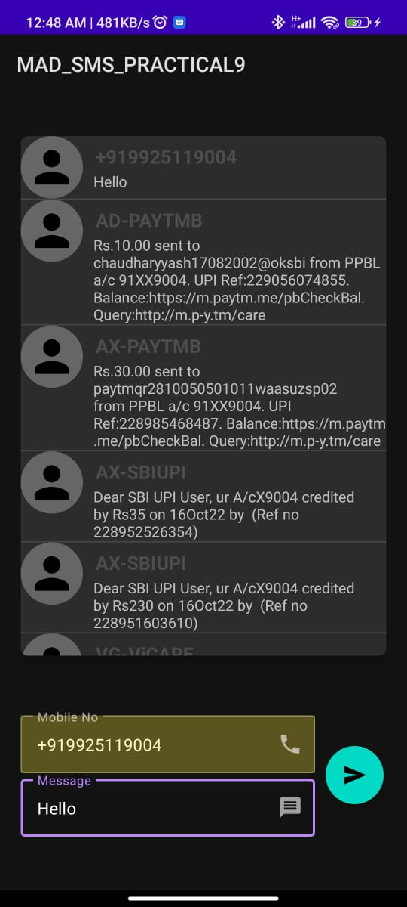 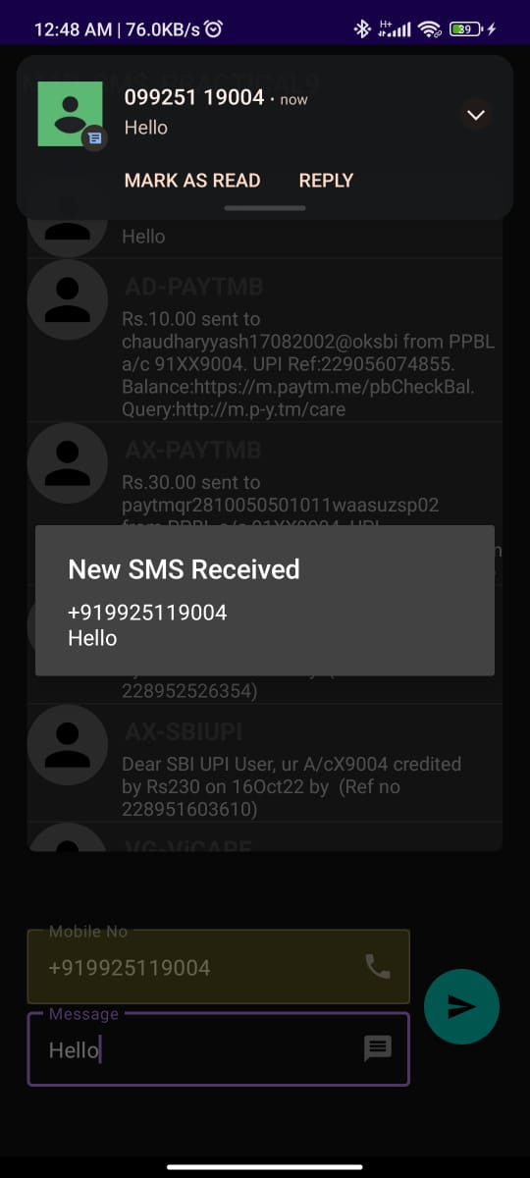

## 

## AndroidManifest.xml:-

## <?xml version="1.0" encoding="utf-8"?> <manifest xmlns:android="http://schemas.android.com/apk/res/android" xmlns:tools="http://schemas.android.com/tools" package="com.example.madpractical9_20012011055"> <uses-permission android:name="android.permission.RECEIVE_SMS" /> <uses-permission android:name="android.permission.READ_SMS" /> <uses-permission android:name="android.permission.SEND_SMS" /> <application android:allowBackup="true" android:dataExtractionRules="@xml/data_extraction_rules" android:fullBackupContent="@xml/backup_rules" android:icon="@mipmap/ic_launcher" android:label="MAD_SMS_PRACTICAL9" android:roundIcon="@mipmap/ic_launcher_round" android:supportsRtl="true" android:theme="@style/Theme.MADPRACTICAL9_20012011055" tools:targetApi="31"> <receiver android:name=".SMSBroadcastReceiver" android:enabled="true" android:exported="true"> </receiver> <activity android:name=".MainActivity" android:exported="true"> <intent-filter> <action android:name="android.intent.action.MAIN" /> <category android:name="android.intent.category.LAUNCHER" /> </intent-filter> </activity> </application> </manifest>